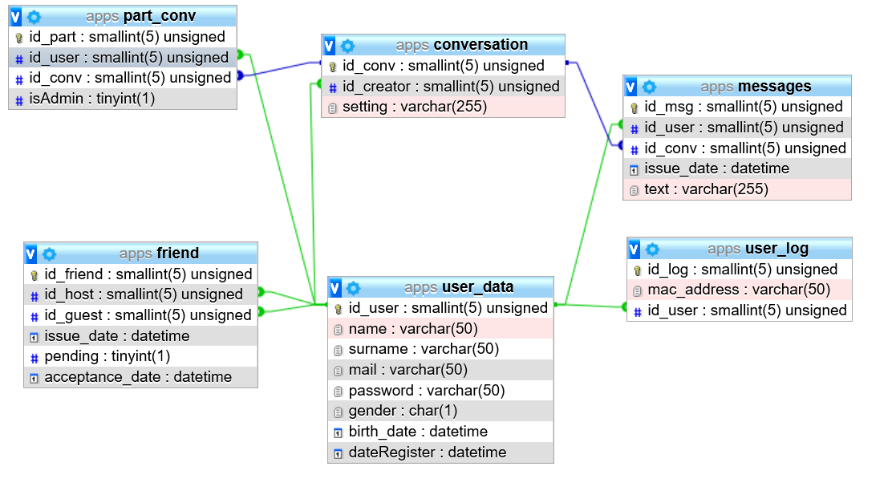

Diagram UML Data Base

On this diagram we can see how working front end and principally data Base. The data base is so important in apps because we need to collect information of users. User data is the main table in database is user_data. And every other table are link with them. Now I will describe each table.

**Table 1. User_Data**

|  |  |  |  |
| --- | --- | --- | --- |
| User_Data – Data about all users | | | |
| **Attribute** | **Description** | **Required** | **Type** |
| *ID User* | incremented for each new user and is useful to connect and recognize everyone. (Primary key, autoincrement | ✓ | int |
| *Name* | save during registration it’s a public information for add friend. | ✓ | Varchar(255) |
| *Surname* | save during registration, cannot be changed. | ✓ | Varchar(255) |
| *Mail* | save during registration it is important for us to share information about apps. | ✓ | Varchar(255) |
| *Password* | save during registration crypted information for | ✓ | Varchar(255) |
| *Gender* | save during registration | ✓ | char |
| *Birthday* | save during registration | ✓ | Datetime |
| *Date register* | save during registration | ✓ | Datetime |
|  |  |  |  |

**Table 2. friend**

|  |  |  |  |
| --- | --- | --- | --- |
| friend – Data about friend added | | | |
| **Attribute** | **Description** | **Required** | **Type** |
| *ID Friend* | Same ID of user has been add. PK | ✓ | Int |
| *ID Host* | ID of user add other | ✓ | Int |
| *ID Guest* | ID of the receiver | ✓ | Int |
| *Issue Date* | Date of sent request | ✓ | DateTime |
| *Pending* | Information about pending request | ✓ | Int |
| *Acceptance Date* | Date of accept request | ✓ | DateTime |

**Table 3. User_log**

|  |  |  |  |
| --- | --- | --- | --- |
| User_log – Data about login of user | | | |
| **Attribute** | **Description** | **Required** | **Type** |
| *ID User* | incremented for each new user and is useful to connect and recognize everyone. (Primary key, autoincrement | ✓ | int |
| *ID log* | ID for login-in (PK) | ✓ | int |
| *Mac Address* | Information about personal address of hardware |  | Varchar(255) |

**Table 4. Messages**

|  |  |  |  |
| --- | --- | --- | --- |
| Messages – Data about messages | | | |
| **Attribute** | **Description** | **Required** | **Type** |
| *ID msg* | ID to recognize the messages (PK) | ✓ | int |
| *ID user* | ID user who sent message | ✓ | Int |
| *ID conv* | ID to recognize conversation | ✓ | Int |
| *Issue date* | Date when message has been sent | ✓ | DateTime |
| *Text* | Content of messages | ✓ | Varchar(255) |

**Table 5. Conversation**

|  |  |  |  |
| --- | --- | --- | --- |
| Conversation – Information for Conversation | | | |
| **Attribute** | **Description** | **Required** | **Type** |
| *ID Conv* | ID for recognize the conv (PK) | ✓ | int |
| *ID creator* | ID of user who creating conversation | ✓ | Varchar(255) |
| *Setting* | Parameter about conversation | ✓ | Varchar(255) |

**Table 6. Part conv**

|  |  |  |  |
| --- | --- | --- | --- |
| Part conv: Personal information about Conv | | | |
| **Attribute** | **Description** | **Required** | **Type** |
| *ID part* | ID of participant | ✓ | Int |
| *ID conv* | ID of conversation | ✓ | Int |
| *ID user* | save during registration, cannot be changed. | ✓ | Int |
| *Is Admin* | ID of admin for conversation | ✓ | Int |